Prognostic Biomarkers Across 33 TCGA Cancers
Oct 12, 2026 · @Denver Ncube
Across 33 TCGA cancers, survival biology splits into one programme that is shared and one that diverges. High proliferation predicts worse survival in every cancer where it is significant (216 of 216 gene-level hits), while circadian-clock output and retained tissue metabolism predict better survival. Immune and interferon genes divide the cancers: protective in melanoma, head and neck, endometrial and bladder cancer, but risk-associated in glioma, clear-cell renal and prostate cancer.

The shared risk programme: proliferation
High expression of cell-cycle and mitotic genes predicts shorter survival in every cancer where it reaches significance, and never the reverse. Across the 13 cohorts with replicated signal, a 40-gene proliferation set produced 216 FDR-significant gene-cohort hits: all 216 were risk-associated, and 215 kept that direction on held-out patients.
The programme is a single biological axis rather than a list of unrelated genes. It spans the mitotic spindle and checkpoint (AURKB, CDC20, BUB1, TTK, TPX2, KIF20A), the G2/M transcriptional drivers FOXM1 and MYBL2, the anti-apoptotic survivin BIRC5, the proliferation marker MKI67, and nucleotide synthesis for DNA replication (RRM2, TK1).
Gene | Role | Cohorts (FDR < 0.05) | Median HR per SD
TPX2 | Spindle assembly, activates Aurora A | 9 | 1.64
UBE2C | APC/C ubiquitin ligase, mitotic exit | 8 | 1.56
KIF20A | Mitotic kinesin, cytokinesis | 8 | 1.56
AURKB | Chromosome passenger kinase | 8 | 1.47
CDC20 | APC/C activator, spindle checkpoint | 7 | 1.61
CEP55 | Cytokinesis, abscission | 7 | 1.53
BIRC5 | Survivin, inhibitor of apoptosis | 7 | 1.50
MKI67 | Proliferation marker (Ki-67) | 7 | 1.47
RRM2 | Ribonucleotide reductase, dNTP supply | 7 | 1.46
FOXM1 | G2/M master transcription factor | 7 | 1.45
The signal is strongest in mesothelioma (38 proliferation hits), lower-grade glioma (36), liver (36) and lung adenocarcinoma (34), followed by prostate (23), melanoma (21) and clear-cell renal cancer (16). It is weak or absent in head and neck, sarcoma, bladder and endometrial cancer. In those, survival tracks the tumour microenvironment more than tumour growth rate.
For LGG, proliferation partly reflects grade and IDH status: faster-growing, IDH-wild-type gliomas behave like glioblastoma. For PRAD, the endpoint is progression-free interval, so the signal points to proliferation as a driver of recurrence rather than death. A one-SD rise in any of these genes raises the hazard by roughly 1.4- to 1.7-fold, about the same across cancers that differ in tissue of origin.

Protective programmes
Genes linked to longer survival mark tumours that still behave like their tissue of origin. Of 426 genes protective in two or more replicated cohorts, three groups stand out: the circadian clock output arm, normal-tissue metabolism, and a Polycomb tumour suppressor. Protective genes concentrate in KIRC (234 genes) and LGG (203), then SKCM (126) and HNSC (83).
Circadian clock output. The repressor and output arm of the molecular clock is protective wherever it is significant: PER2, PER3, CRY2, NR1D2 and the PAR bZIP transcription factors DBP, TEF and HLF. Together they give 19 protective hits in KIRC, KIRP, LGG, LIHC, LUAD, MESO, PRAD and HNSC, with no risk-associated hit in any replicated cohort. HLF alone is protective in 6 cohorts (HR per SD 0.53-0.76). The core activators CLOCK and ARNTL (BMAL1) carry no signal. This fits loss of rhythmic clock output, rather than loss of the clock itself, as a feature of aggressive tumours.
Retained normal metabolism. Tumours that keep their tissue's metabolic programme do better:
Gene | Pathway | Protective in (HR per SD)
ALDH2 | Mitochondrial aldehyde detoxification | ACC 0.58, KIRP 0.56, LGG 0.58, LIHC 0.68, LUAD 0.79, MESO 0.55
ABAT | GABA catabolism | ACC 0.40, KIRC 0.74, KIRP 0.57, LGG 0.61, LUAD 0.77, PRAD 0.70
FBP1 | Gluconeogenesis, opposes glycolysis | BLCA 0.77, KIRC 0.63, KIRP 0.58, LUAD 0.75, SKCM 0.76
HMGCS2 | Ketogenesis | KIRC 0.67, LIHC 0.78, PRAD 0.67
ALDH5A1 | GABA shunt (succinic semialdehyde) | LGG 0.49, LIHC 0.72, MESO 0.59
ACOX2 | Peroxisomal fatty-acid oxidation | KIRC 0.76, MESO 0.61, PRAD 0.65
FBP1 is a known tumour suppressor in clear-cell renal cancer, where its loss releases glycolysis and HIF activity; here it is protective in two renal types and three other cancers. Read together, these genes describe a gradient from differentiated oxidative metabolism (better outcome) to dedifferentiated, glycolytic and proliferative tumours (worse outcome).
Polycomb and quiescence. CBX7, a Polycomb repressive complex 1 subunit and reported tumour suppressor, is the most recurrent protective gene (5 cohorts, median HR per SD 0.59). The quiescence and stress-response genes BTG2, NFKBIA and DNAJB9 are protective in 3-4 cohorts each.
T-cell genes, in some cancers. CD5, CD3D, IKZF3, CXCR3, SIT1 and T-cell receptor segments are protective in HNSC, SKCM, UCEC, BLCA and LUAD. The next two sections show this is the main place where cancers disagree.

Which cancers share prognostic biology
The replicated cancers fall into two camps that read the same genes in opposite directions, plus a group that agrees with everyone. For each pair of cancers, the chart shows the share of genes significant in both that carry the same direction of risk.
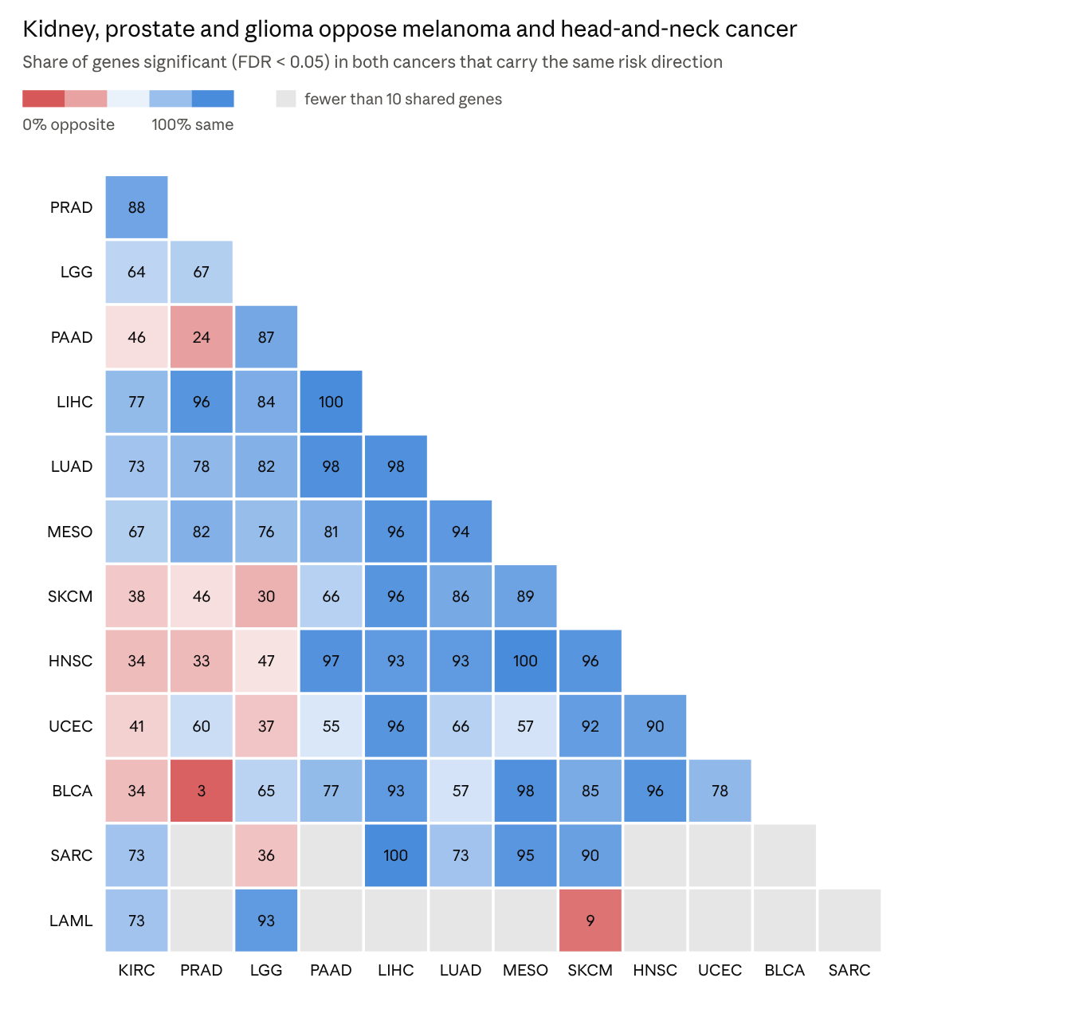
results/_pan_cancer/pan_cancer_gene_hr_long.csv · RNA, 13 replicated cohorts, genes with FDR < 0.05 in both cancers of a pair
- A proliferation core: LIHC, LUAD and MESO. These agree with almost every other cancer (LUAD-LIHC 98%, MESO-LIHC 96%, HNSC-MESO 100%), because their shared genes are mostly the proliferation programme, which is risk-associated everywhere.
- Camp 1: KIRC, PRAD and LGG, with PAAD close to LGG (87%). These agree with each other (PRAD-KIRC 88%) but oppose the second camp: SKCM-LGG 30%, HNSC-KIRC 34%, BLCA-KIRC 34%.
- Camp 2: SKCM, HNSC, UCEC and BLCA. These agree strongly with each other (HNSC-SKCM 96%, UCEC-SKCM 92%).
- The sharpest opposition is BLCA-PRAD: 31 of 32 shared genes point in opposite directions. LAML opposes SKCM on 10 of 11 shared genes.
The split between the camps is not random: the next section shows that immune genes drive it.

Where signals diverge: the immune microenvironment
The same immune genes predict better survival in melanoma, head and neck, endometrial and bladder cancer, and worse survival in glioma, clear-cell renal cancer and prostate cancer. This single axis explains most of the camp split above.
Gene set (curated) | Risk hits | Protective hits | Where risk | Where protective
Interferon / antigen presentation (GBP1/2, OAS1-3, APOL1, STAT1, CXCL9-11, HLA class II, PSMB9) | 46 | 34 | LGG 24, PAAD 8, KIRC 7, LUAD 4 | SKCM 25, BLCA 4, KIRC 2
Cytotoxic T/NK cells (CD8A, GZMA/B, PRF1, NKG7, CD3D/E, CCL5) | 6 | 26 | LGG 4, KIRC 2 | SKCM 13, UCEC 7, HNSC 5, LIHC 1
Stromal / ECM / EMT (collagens, FN1, POSTN, SPARC, FLNC, ANXA2, SERPINE1) | 66 | 2 | MESO 17, LGG 15, KIRC 8, PAAD 8, BLCA 6 | UCEC 1, PRAD 1
Hypoxia / glycolysis (CA9, VEGFA, PGK1, LDHA, ENO1, NDRG1, BNIP3) | 28 | 5 | LUAD 6, LGG 5, LIHC 5, PAAD 4 | KIRC 5
Three biological readings fit these directions, each consistent with published tumour immunology:
- Immune-responsive tumours (SKCM, HNSC, UCEC, BLCA). These are the cancers with high mutation burden or viral antigens, where infiltrating cytotoxic T cells and interferon signalling reflect active anti-tumour immunity. Melanoma alone contributes 25 protective interferon hits and 13 protective cytotoxic hits.
- Immune-suppressive or inflammatory tumours (LGG, KIRC). In glioma, interferon and inflammatory genes (CHI3L1, SERPING1, IFITM3, GBP1, HR per SD up to 2.2) mark the mesenchymal, macrophage-rich, IDH-wild-type state. Clear-cell renal cancer is a known exception to "T cells are good": dense but exhausted CD8 infiltrates predict worse outcome. Here JAK3, CD72, MIR155HG and CXCL13 are risk genes in KIRC but protective in SKCM.
- Kidney hypoxia reverses sign. Glycolytic HIF targets (PGK1, LDHA, ENO1, NDRG1, BNIP3) are protective in KIRC (HR per SD 0.65-0.78) while hypoxia genes are risk-associated elsewhere. In clear-cell renal cancer, VHL loss makes HIF activity constitutive; high HIF-target expression marks the well-differentiated ccA subtype, which has the better prognosis.
Stroma, by contrast, does not diverge: extracellular matrix and EMT genes are risk-associated in 66 of 68 hits, led by MESO and LGG. ANXA2 and FLNC are the exceptions that flip, both protective in a single cohort (UCEC and PRAD respectively).
The most recurrent discordant genes show the same pattern at gene level:
Gene | Risk in (HR per SD) | Protective in (HR per SD) | Biology
GBP2 | KIRC 1.36, LGG 1.31, LUAD 1.27, PAAD 1.87 | BLCA 0.74, SKCM 0.63 | Interferon-induced GTPase
OAS1 | LGG 1.72, LUAD 1.27, PAAD 1.43, PRAD 1.32 | BLCA 0.74, SKCM 0.77 | Interferon antiviral response
APOL1 | KIRC 1.30, LGG 1.49, LUAD 1.42 | BLCA 0.73, SARC 0.65, SKCM 0.74 | Interferon-induced apolipoprotein
ANXA2 | BLCA 1.34, KIRC 1.33, LGG 1.84, LUAD 1.35, PAAD 1.81 | UCEC 0.70 | Plasminogen receptor, invasion
CYP27A1 | LGG 1.70 | HNSC 0.75, LIHC 0.77, LUAD 0.76, PAAD 0.69, PRAD 0.67 | Cholesterol hydroxylation, macrophage marker
Within each cancer these directions replicate on held-out patients (all cohorts for APOL1, ANXA2 and CYP27A1; 5 of 6 for GBP2 and OAS1), so the flips reflect tumour biology rather than noise.

Cancer-specific biomarkers
Beyond the shared programmes, each cancer has leading biomarkers that reflect its own tissue biology. The table lists the strongest protein-coding genes per replicated cohort that were also significant (p < 0.05) on held-out patients. Values are HR per SD on training / held-out patients.
Cancer | Leading risk genes | Leading protective genes | Biological theme
KIRC (OS) | TCIRG1 1.91 / 1.55, THBS3 1.71 / 1.63, COL7A1 1.58 / 1.49, CKAP4 1.59 / 2.04 | SLC16A12 0.55 / 0.55, SORBS2 0.57 / 0.53 | Loss of renal tubular transporters, gain of matrix and V-ATPase
LGG (OS) | EMP3 2.68 / 2.03, IGFBP2 2.26 / 2.58, MEOX2 2.18 / 1.74, TNFAIP6 2.11 / 1.75 | FAM133A 0.42 / 0.07 | Markers of IDH-wild-type, mesenchymal glioma
MESO (OS) | UHRF1 2.62 / 1.96, CDCA2 2.45 / 2.53, LMNB2 2.42 / 2.56, IQGAP3 2.39 / 2.27 | FAAH2 0.57 / 0.30 | The strongest proliferation effects in the dataset
LIHC (OS) | G6PD 1.60 / 2.09, KPNA2 1.74 / 1.66, ENO1 1.68 / 1.66 | CFHR3 0.73 / 0.43, PON1 0.72 / 0.58 | Glycolysis and pentose phosphate up; hepatocyte secretory function lost
LUAD (OS) | DKK1 1.54 / 1.32, FAM83A 1.56 / 1.50, LDHA 1.48 / 1.58, GAPDH 1.49 / 1.53 | CXCL17 0.77 / 0.76 | Glycolysis and Wnt-pathway antagonist DKK1
PRAD (PFI) | UBE2C 1.58 / 2.13, CDC20 1.66 / 2.04, ABCC5 1.64 / 1.98, TACC3 1.59 / 1.94 | SPOCK3 0.72 / 0.35, KCND3 0.71 / 0.46 | Proliferation drives biochemical recurrence
PAAD (OS) | ANLN 1.62 / 2.89, GJB3 1.77 / 1.68, MYEOV 1.60 / 1.65, ANO1 1.61 / 1.97 | TLE2 0.54 / 0.54, ARNT2 0.65 / 0.40 | Consistent with the basal-like (squamous) subtype being aggressive
SKCM (OS) | SPRR2F 1.32 / 1.61, KRT78 1.34 / 1.83, S100A12 1.30 / 1.65 | GBP4 0.62 / 0.64, GBP2 0.63 / 0.56, CCL8 0.63 / 0.61, APOBEC3G 0.64 / 0.65 | Interferon-gamma response protective; keratinocyte genes risk
UCEC (OS) | MGAT4A 1.69 / 1.73, MBOAT2 1.68 / 2.47 | PGR 0.57 / 0.49, SCGB2A1 0.63 / 0.58 | Hormone-responsive endometrioid differentiation protective
HNSC (OS) | STC2 1.35 / 1.45, EFNB2 1.37 / 1.58, TNFRSF12A 1.37 / 1.50, SLC2A3 1.28 / 1.56 | CCR7 0.71 / 0.60 | Hypoxia (GLUT3, STC2) risk; lymphocyte homing protective
BLCA (OS) | EMP1 1.48 / 1.70, HEYL 1.41 / 1.62, RUNX2 1.39 / 1.47, SERPINB2 1.25 / 1.65 | HNF1B 0.77 / 0.58 | Basal and mesenchymal features risk; luminal HNF1B protective
SARC (OS) | NETO2 1.72 / 1.67, LAPTM4B 1.56 / 1.91, SQLE 1.49 / 2.11 | ALDH1A1 0.58 / 0.58, CCDC69 0.60 / 0.52 | Cholesterol synthesis (SQLE) risk
LAML (OS) | CBR1 2.11 / 2.26, PTP4A3 1.88 / 1.96, TREML2 1.86 / 2.34 | SERINC5 0.57 / 0.37 | PTP4A3 (PRL-3) is a reported adverse marker in AML
Three observations stand out:
- Melanoma's top biomarkers are all protective. Its six strongest replicated genes are interferon-gamma response genes (GBP2, GBP4, CCL8, APOBEC3G). Its risk genes are keratinocyte genes (SPRR2F, KRT78), which in TCGA melanoma mark the keratin-high subtype with poorer outcome.
- Differentiation markers are protective across tissues: PGR in endometrium, HNF1B in bladder, CFHR3 and PON1 in liver, SLC16A12 in kidney. This matches the metabolic pattern in the protective programmes section.
- Glycolysis is a recurring risk theme in LIHC, LUAD and HNSC (ENO1, G6PD, LDHA, GAPDH, SLC2A3), but not in KIRC, where HIF-driven glycolysis marks the better ccA subtype.
The two underpowered cohorts carry large effects on few events: adrenocortical carcinoma (8 test events; HOXC11 and HOXC13 HR per SD about 1.8) and uveal melanoma (6 test events; CITED1 HR per SD 2.3). They are suggestive, not established.

Protein-level biomarkers
Protein measurements (RPPA, about 220-460 antibodies per cancer) confirm the RNA picture where they overlap, and disagree in ways that are themselves biological. 357 antibody-cohort pairs reached FDR < 0.05. Where the antibody targets a total protein that also has an RNA measurement, protein and RNA agree on risk direction in 55 of 69 pairs (80%), and in 37 of 47 (79%) when the RNA effect is itself significant.
The most consistent protein biomarkers:
Protein | Risk direction in (protein HR per SD) | Matching RNA HR per SD | Biology
IGFBP2 | LGG 1.76, GBM 1.39, KIRC 1.22 | LGG 2.26, GBM 1.18, KIRC 1.15 | IGF-binding protein; glioma aggressiveness marker
PAI-1 (SERPINE1) | KIRC 1.55, GBM 1.35, LGG 1.30 | KIRC 1.27, GBM 1.17, LGG 1.69 | Plasminogen activator inhibitor; invasion and stroma
TFRC | LGG 1.47 | LGG 1.90 | Transferrin receptor; iron uptake by proliferating cells
EGFR | LGG 1.58, SKCM 1.42 | LGG 1.46, SKCM 1.16 | Growth-factor receptor
WEE1, CDK1, Cyclin B1 | LGG 1.60, LGG 1.29, KIRC 1.38 | LGG 2.17, LGG 1.63, KIRC 1.40 | G2/M checkpoint; the proliferation axis at protein level
GATA3 | protective in BLCA 0.70 | BLCA 0.80 | Luminal bladder differentiation
CD38 | protective in LGG 0.66 | LGG 0.73 | Immune and NAD metabolism marker
Some protein and RNA directions disagree, and two of these have clear biological reasons:
- p53 in LGG: p53 protein is protective (HR per SD 0.61) while TP53 RNA is risk-associated (1.26). Mutant p53 protein accumulates when it is stabilised, which in glioma marks the IDH-mutant astrocytoma lineage with longer survival. Here the protein reads mutation status, not expression.
- TAZ and p21 in KIRC: both proteins are risk-associated (1.27 and 1.44) while their RNA is protective (0.74 and 0.81). This suggests post-transcriptional stabilisation in aggressive renal tumours rather than higher transcription.
- FOXM1, CD31 and IGFBP3 in LGG are protective at protein level but risk-associated at RNA level. These are more likely antibody specificity or tissue-composition effects than biology, and should not be read as biomarkers.
RPPA adds the strongest evidence in the four cancers where its own signal replicates on held-out patients: KIRC, LGG, SARC and SKCM. Across all cancers, IGFBP2 and PAI-1 are the protein biomarkers most worth following up.

Candidate biomarkers for follow-up
The strongest candidates combine recurrence across cancers, held-out replication and, where available, protein support. They fall into three tiers by intended use.
Candidate | Use | Evidence | Where it applies
Proliferation score (TPX2, UBE2C, KIF20A, AURKB, CDC20, BIRC5, MKI67, FOXM1) | Pan-cancer risk marker | 216/216 hits risk; 215 replicate; Cyclin B1, CDK1 and WEE1 proteins agree | MESO, LGG, LIHC, LUAD, PRAD, SKCM, KIRC
Circadian output score (HLF, TEF, DBP, PER2/3, CRY2, NR1D2) | Pan-cancer favourable marker | 19 protective hits, none risk; all HLF hits replicate | KIRC, KIRP, LGG, LIHC, LUAD, MESO, PRAD, HNSC
Immune / interferon score (GBP2, GBP4, CCL8, CD8A, GZMA, CXCL9) | Context-dependent marker; sign must be set per cancer | Protective in SKCM, HNSC, UCEC, BLCA; risk in LGG, KIRC, PAAD | Not usable as a single pan-cancer marker
IGFBP2 | Glioma and renal risk marker | RNA and protein both risk in LGG, GBM, KIRC | LGG, GBM, KIRC
PAI-1 (SERPINE1) | Invasion and stroma marker | RNA and protein both risk in KIRC, GBM, LGG | KIRC, GBM, LGG
FBP1, ALDH2, ABAT | Differentiated-metabolism markers | Protective in 5-6 cancers each, all replicate | Renal, liver, lung, glioma
CBX7 | Tumour-suppressor candidate | Protective in 5 cancers (median HR per SD 0.59) | KIRC, LGG, MESO, PAAD, SKCM
PGR, HNF1B, GATA3 | Lineage-differentiation markers | Protective in UCEC, BLCA; GATA3 protein agrees | UCEC, BLCA
Two hypotheses follow directly from these results and can be tested on the same data:
- A two-axis model of prognosis. A proliferation score and an immune score may together explain most cross-cancer variation, with the immune weight changing sign by cancer type. A model with a cancer-by-immune interaction term would test this.
- Clock output as an independent marker. If HLF, TEF and PER3 remain protective after adjusting for the proliferation score, the circadian signal is not just a proxy for slow growth.

How to read the evidence
- Hazard ratios are per standard deviation of training-set expression, from a Cox model per gene on 80% of patients. "Replicates" means the same direction on the held-out 20%.
- Significance is Benjamini-Hochberg FDR < 0.05 within each cancer. Recurrence counts use the 13 RNA cohorts whose signal passed held-out replication; ACC and UVM are reported separately because they have fewer than 10 test events.
- Endpoints are overall survival in 12 of the 13 replicated cancers, and progression-free interval in PRAD, ACC and UVM.
- Gene sets for proliferation, immune, stroma, hypoxia and the circadian clock were curated for this report from standard pathway membership. They are descriptive groupings, not a formal enrichment test.
- Biological explanations are interpretations consistent with published tumour biology. The data establish the associations and their directions, not the mechanisms.
Sources: ~/work/CPSM_agent/results/_pan_cancer/ (pan_cancer_gene_hr_long.csv, pan_cancer_recurrent_genes_primary.csv, pan_cancer_recurrent_genes_extended.csv, pan_cancer_cohort_tiers.csv), read on 12 Oct 2026. The pipeline and its corrections are described in the companion CPSM Pan-Cancer and Proteomics Survival Report.

